**Dummy Variables**

Instructions:

Please share your answers filled inline in the word document. Submit code files wherever applicable.

Please ensure you update all the details:

**Name:N.Harsha vardhan**

**Batch Id: nharsha569103528**

**Topic: Data Pre-Processing**

**Problem Statement:**

Data is one of the most important assets. It is often common that data is stored in distinct systems with different formats and forms. Non-numeric form of data makes it tricky while developing mathematical equations for prediction models. We have the preprocessing techniques to make the data convert to numeric form. Explore the various techniques to have reliable uniform standard data, you can go through this link:

<https://360digitmg.com/mindmap-data-science>

1. Prepare the dataset by performing the preprocessing techniques, to have all the features in numeric format.

|  |  |  |  |  |
| --- | --- | --- | --- | --- |
| Index | Animals | Gender | Homly | Types |
| 1 | Cat | Male | Yes | A |
| 2 | Dog | Male | Yes | B |
| 3 | Mouse | Male | Yes | C |
| 4 | Mouse | Male | Yes | C |
| 5 | Dog | Female | Yes | A |
| 6 | Cat | Female | Yes | B |
| 7 | Lion | Female | Yes | D |
| 8 | Goat | Female | Yes | E |
| 9 | Cat | Female | Yes | A |
| 10 | Dog | Male | Yes | B |

**Hints:**

For each assignment, the solution should be submitted in the below format.

1. Work on each feature to create a data dictionary as displayed in the image displayed below: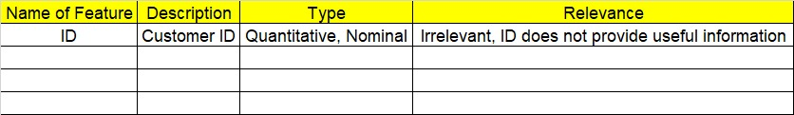
2. Refer to the animal_category.csv data set.
3. Research and perform all possible steps for obtaining the solution.
4. All the codes (executable programs) should execute without errors.
5. Code modularization should be followed.
6. Each line of code should have comments explaining the logic and why you are using that function.